**The Diaper Manufacturing Process**

*Kumar Singaram*

**Business Understanding**

From our understanding, the diaper manufacturing process has 3 separate components listed below:

* Absorbent Pad
* The Top Sheet
* The Backing Sheets

The manufacturing process itself features four main steps:

1. The absorbent is vacuum formed
2. The pad is attached to a permeable top sheet and bottom sheet
3. Components are sealed together by heat or ultrasonic vibrations
4. Elastic fibers are attached to sheets to gather the edges of the diaper into a proper shape

The formation of the absorbent is the most important step in the process and most complex. It is formed on a movable conveyor belt that passes through a long ‘forming chamber’. See image below:

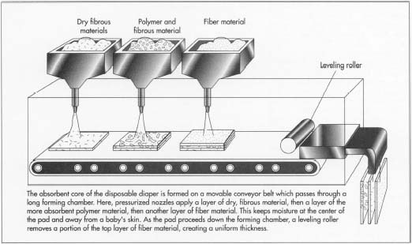

In this process, there are two main methods that are important.

The first is a method that involves injecting the polymer into the same feed stock that supplies the fibers. The method produces a pad that has absorbent polymer dispersed evenly throughout. The problem here is that a loss of absorbent can occur because the fine particles are pulled through the perforations in the conveyor by the vacuum. This can also lead to uneven absorbent in the pad.

The second method involves application of the absorbent material onto the top surface of the pad after it has been formed. This can produce a pad with absorbent material concentrated on its top side without much absorbency throughout the pad. It also may lose some of the polymer applied to its surface and cause gel blocking. Moisture can get trapped in the outer layer without having a chance to diffuse to the center. This can lead to discomfort for the wearer.

In our analysis, we would like to understand the complex parts of the process leading to the greatest number of issues. The focus should specifically be on parts of the process that are unhealthy for the consumer and must be addressed. Measuring aspects of quality control is a good place to start.

In this area, there seems to many issues associated with the diaper’s ability to soak up moisture, which is essential for the product to absorb and retain body fluids. This is typically due to the ratio of polymers to fibers in the paid. The ratio should be about 75:25 to 90:10.

More critical than even the diaper’s ability to soak up moisture is the distribution of particles throughout the pad. Particles with a mass median size of greater than or equal to 400 microns works very well with the fibers to enhance the rate at which the fluid is transported from the body. Gel blocking can occur if the particles vary outside of this range, meaning the polymer will deform and water cannot reach the inner pad particles.

The demand wettability and gravimetric absorbance test can be used for checking diaper absorbency. The test simulates the effect of a baby sitting on a wet diaper. If the absorbency of the diaper is at least 24 ml/g, the quality is acceptable. The diaper’s fit and comfort can be measured using the melt characteristics of the nonwoven fabrics used to form the diaper’s shell. The material becoming too soft can be due to the different melting points in the material. The alignment of the components must be correct to prevent leakage.

**Data Requirements**

We specifically need data collected from the quality control portion of the process. This relates to data on the ratio of polymer and fiber in the absorbency pads. We need to check the variation of the ratio across diapers, so we can tighten the process in the future.

We also want the ratio of size and distribution of polymer particles to be reasonable. By keeping the size of particles above 400 microns, we can help prevent gel blocking.

As far as the diaper’s fit and comfort, optimizing the melt characteristics would make the most impact. Specifically, data on the ‘melt blown’ method in the dry laid process. Diapers with varying melting points are more likely to be uncomfortable for the wearer. We can use data from the demand wettability and gravimetric absorbance tests to get a better understanding of diaper absorbency.

Finally, measuring the alignment of the different components would help us address any leakage that may occur for the wearer. Having data on this part of the process can inform us on the optimal alignment of the diaper.

Other than the process focused data requests, it would also be useful to have the time it takes for a diaper to be manufactured. This can help us understand whether process time is a factor in quality.